CFSD has been closely following the planned replacement of the iconic LIBOR financial benchmark for liquidity facilities with a new benchmark, the Secured Overnight Finance Rate or SOFR. The transition to SOFR is under the auspices of the Alternate Rate Replacement Committee (ARRC), which is primarily comprised of federal banking authorities and global banks and their counsel. As our client base is exclusively utility borrowers and their other corporate entities, we are looking at these developments from the borrowers’ point of view. Some basic points about SOFR:
- The ARRC is encouraging transition to SOFR within the next few years, and some banks and their clients have already begun using variations of the new rate formula.
- The ARRC has determined that most existing contracts for cash products referencing LIBOR don’t provide for the cessation of LIBOR in practical terms and have fallbacks that would not be economically appropriate.
- As the following graph illustrates, SOFR will represent a new and potentially significant variation from both LIBOR and CP.
- SOFR represents actual transactions (about $800 billion daily in the U.S. alone). In contrast, LIBOR rates are agreed upon daily by a small group of global bankers and thus are subject to manipulation.
- By their basic nature, SOFR rates will be more volatile than LIBOR. This will present a timing challenge to corporate cash managers.
- The ARRC is working apace on “adders” and other adjustment mechanisms to adapt SOFR to a LIBOR-like usage and tenor. These adjustment mechanisms will result in added rate uncertainty.
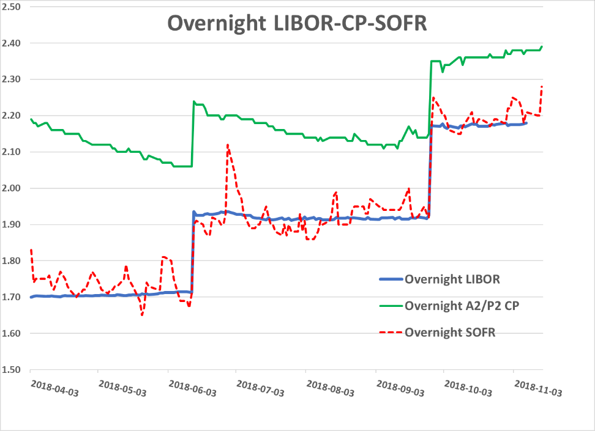
Source: NY Federal Reserve and FRED (St. Louis Federal Reserve).
In addition to our ongoing intensive research on SOFR, LIBOR, and commercial paper rates, several of our partners have deep experience in helping to formulate the original floating rate revolving credit agreements. We would be pleased to brief you on our thoughts regarding the new SOFR metric.

